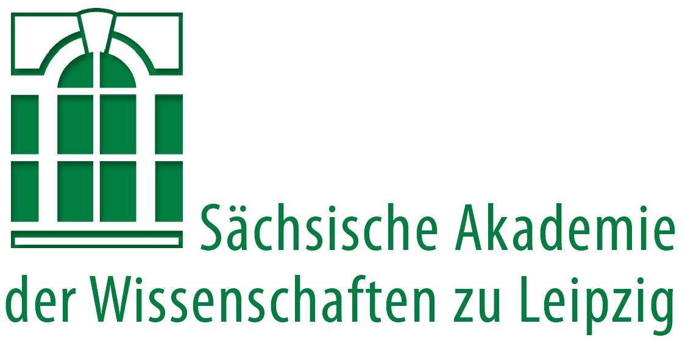
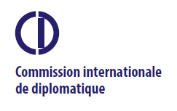

Paris/Ghent/Leipzig, 09/2018

Press release

International conference on diplomatics held in Leipzig for the first time

Following up Amsterdam, Paris and Rome: In early October 2018, the Commission internationale de diplomatique in cooperation with the Saxon Academy of Sciences and Humanities in Leipzig is hosting the 15th International Congress of Diplomatics in Germany. Experts from all over Europe will present new perspectives on international treaties from the medieval and early modern periods. The often protracted and difficult negotiations prior to their signing will be of particular interest.

Between 4 and 6 October 2018, the Commission internationale de diplomatique (CID) reunites researchers from 16 European countries in the Saxon Academy of Sciences and Humanities in Leipzig. International treaties concerning alliances, unions and peace agreements as well as other documents related to conflict settlement during the Euro-Mediterranean Middle Ages and the early modern period will be in the centre of the international congress, which thus aims at making an important contribution to a coalescing modern Europe. Especially in the light of the current political situation, taking a look back opens up new perspectives.

Today, diplomatic agreements are often reduced to meetings of leading representatives, who sign treaties on behalf of the states involved. The commonly protracted and difficult negotiations preceding the conclusion of a treaty often remain unconsidered. The presentations will focus not only upon the finalized treaty documents but will study for the first time also their development via intermediate documentary stages as well as their subsequent use. Compared to previous research, this approach is innovative in several aspects.

For the first time, the sources will be analysed systematically, based on common diplomatic and historical criteria. The treaties examined represent cases from Latin and Byzantine Europe as well as agreements between Christian and Islamic powers in the Mediterranean region. From a modern perspective, they are related to the history of more than 30 countries in Europe and the Mediterranean.

The conference on diplomatics with the title Sources for the History of ‘International’ Relations between Political Centres in Europe and the Mediterranean (ca. 800–1600): Letters – Charters – Treaties helps also to understand the development of modern Europe. For example, the first panel will cover documents which were essential for the formation of the Kalmar Union (Denmark, Norway, Sweden) at the end of the 14th century and already show differing interests and concepts of a union. Denmark and Norway remained part of this union for centuries (until 1814), whereas Sweden left it already in the 15th century. The second panel focusses on selected treaties and related documents concerning the Polish-Lithuanian union which show the steps on the way from a balanced to a Polish-dominated union. Another main point of the conference will be the first general European peace treaty which was signed 1518 in London and intended to integrate most countries of Europe.

Further information: www.saw-leipzig.de/cid2018.

Contact:
Prof. Dr. Wolfgang Huschner
Full member of the Saxon Academy of Sciences and Humanities in Leipzig
Head of the Philological-Historical Class
Historisches Seminar
Universität Leipzig
Beethovenstraße 15
04107 Leipzig

Tel.: +49 341 97370-80/81
huschner@rz.uni-leipzig.de

Ere-Prof. Dr. Thérèse de Hemptinne
Secretary General of the Commission internationale de diplomatique

Ghent University
Department of Medieval History
Faculty of Arts and Humanities
Sint-Pietersnieuwstraat 35
9000 Ghent, Belgien

Tel.: +32 473 52 86 53
Therese.DeHemptinne@UGent.be

Further information
CID
The Commission internationale de diplomatique is an international commission dedicated to the study of medieval and early modern documents and charters based in Paris. It is a member of the International Committee of Historical Sciences. Currently, the CID consists of approximately 80 members from many countries of the world. Its declared aim is to promote the international exchange between scholars of diplomatics and other fields of humanities. For this purpose, the CID has been organising conferences on selected topics related to diplomatics periodically since 1965, most recently 2009 in Sankt Pölten, 2012 in Paris and 2015 in Rome. Moreover, it hosts separate panels within the conferences of the International Committee of Historical Sciences, most recently 2010 in Amsterdam and, again, 2020 in Poznań.
https://cidipl.org/

Saxon Academy of Sciences and Humanities in Leipzig
Founded in 1846 under the name of Royal Saxon Society for the Sciences, the Saxon Academy of Sciences and Humanities is rooted in the idea of the academy formed by Leibniz to unite "theoriam cum praxi". More than 200 scientists of all disciplines meet regularly to exchange views, examine methods and results of specialist studies in interdisciplinary discussion and engage in long-term basic research. Right now, the Academy is responsible for more than 20 research projects in the humanities. The Academy looks back on a particularly long tradition concerning the compilation of dictionaries. They cover a broad range of languages and dialects including, for example, Ancient Egyptian, Old High German and large-area dialects. The Academy's research also focuses on history and regional studies. Annotated editions of collected works and editions of letters also deserve to be mentioned, as well as studies from the field of the history of science.

www.saw-leipzig.de

